

**Seattle Emergency Communications Hubs**

**Hubs win honorable mention from FEMA**

The Hub in a Box program was awarded a national Honorable Mention from the Federal Emergency Management Agency (FEMA) in the category of Technology Innovation. Funded by the Seattle City Council at our request, the Hub in a Box program provides a small amount of money to directly purchase basic equipment that a hub uses to help a neighborhood level response after a disaster. This will allow neighbors to help neighbors while the city is coordinating the larger, city wide response. We were awarded $18,000 in 2016 and were able to provide equipment for 11 hub locations throughout the city, with an emphasis in neighborhoods that typically don’t have the money to front costs, as is typically done with the city’s existing Neighborhood Matching Fund program.

**What we are learning from the recent natural disasters**

**and human caused events**

**What we are learning from the recent natural disasters and human caused events**

**Las Vegas and Stop the Bleed**

The horror of being in a crowd during a shooting event was terrifying for the people at the Las Vegas concert, where gunfire killed and injured over 500 people.  Many people helped in the immediate response; people who wanted to help, people who had some training in first aid and off-duty first responders with greater skills.  In Seattle, we have local classes called “Stop the Bleed” which are a way for you to increase your skills and ability to help in a traumatic disaster.  You will learn the steps to take action to stop severe bleeding to save lives.  Visit our calendar to find any upcoming classes or visit their website at [Stop The Bleed](https://readyseattle.us9.list-manage.com/track/click?u=15c317f52899487470ba6529b&id=220aee8151&e=0b97fdd754)

**Mexico’s earthquake**

Earthquakes are one of the top 5 possible natural disasters that can occur here in Seattle.  It was inspiring to see how all the people in Mexico City responded to help their neighbors and strangers caught by the 8.1 earthquake.   It was chaotic but people were not deterred by the situation; they wanted to help!  In particular we were struck by the people with building construction or inspection skills who went from building to building helping to detect any buildings that had significant structural damage and which should be evacuated or not entered.  They called themselves the “building doctors”.   
We would love to see an movement here in Seattle that takes the time in advance of an earthquake to get the training to be able to help do the same here; architects, construction professionals, structural engineers – they could come to a hub and help us identify which buildings to NOT set up shelters in while we wait for the formal Red Cross shelters to be established (it’s estimated it would take 4 to 5 days for any formal shelters to be established after a significant earthquake like one produced by a rupture of the Cascadia Subduction Zone).  If you can help do something about this, please [contact us](https://readyseattle.us9.list-manage.com/track/click?u=15c317f52899487470ba6529b&id=69a5a42d46&e=0b97fdd754)!

**Hurricane Harvey**

What can be more inspiring than the Cajun Navy!  We may never get a hurricane here that floods our city, but think what would happen if the bridges go down?  We’d be back to using mosquito fleets to get across the lakes, over the rivers, out to the islands.  You might not think you have a skill that could be used at a hub, but you might be one of those people who help people get to a dialysis clinic, or reunite parents with their children who go to school in a different area of town than where their parents work.  No skill or resources is too small!

**Hurricanes Maria and Irma**

It’s too early to say how it ends in Puerto Rico, as we write this, supplies were just getting to the more remote villages. We know supplies will be tight if we get cut off from normal supply lines, which is why FEMA now says you should be prepared to be on your own for 2 weeks.  Yep, that’s sounding about right!  
For the response in Florida it wasn’t sounding too bad…and then word of the crippled nursing home came out.  Could that have been avoided if the nursing home had been better connected into the community surrounding it?  We don’t know but it reinforces the message that we are all vulnerable at some point and having people who can ask if we need help might be the lifeline to survival.  Getting to know your neighbors is an important first step

**Hub and Spokes drill review**

Several hundred volunteers and neighbors joined together to practice in our last drill.  It was a wonderful turn out and great practice session for the hubs.  The 11 hubs who participated this year ranged from well-seasoned locations to several practicing for the first time.  We had several specific objectives to work on this year, ranging from improving the flow of information through the hubs, testing our new Universal Graphics Communications Card and informational signs to managing a heavy radio traffic load.  We have collected our feedback and will create some steps and action plans that address places we want to improve (handwriting, at the top again!)  As always, the volunteers all learned something new and the spontaneous volunteers who stepped forward to help were fabulous!  We thank everyone who helped make this drill possible, including our partners at the [Auxiliary Communications Service (ACS)](https://readyseattle.us9.list-manage.com/track/click?u=15c317f52899487470ba6529b&id=72291558af&e=0b97fdd754)

Broadview Hub visitors check out the Needs board

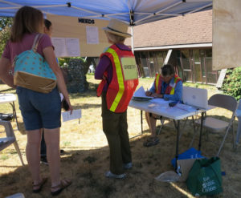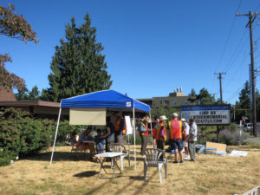

Broadview Hub crew

High Point Hub Greeters with a young citizen actor

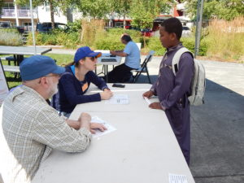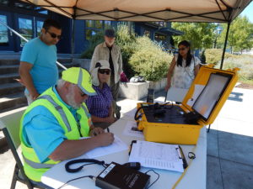

High Point Hub Radio Operator and volunteers

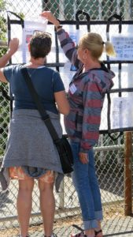

Alaska Junction Hub message pocket board

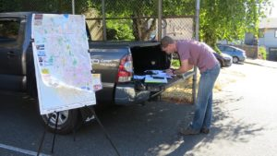

Alaska Junction Hub, any surface will do!

Rainier Beach Hub in action  
  
  
Rainier Beach Radio Station

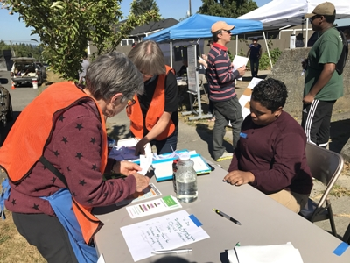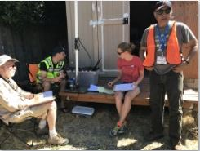

Lake City Information tent  
  
  
Lake City maps and forms

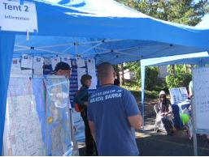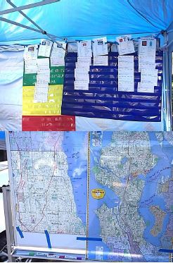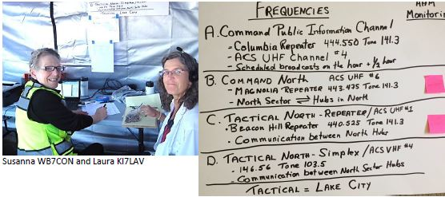

Lake City Radio Tent

**It was a busy summer and fall**

First, welcome to you if this if your first newsletter from the Seattle Hubs and thank you for your interest in us and in getting your community ready to respond in a disaster.  Our main message this year has been “if you’re prepared, then you can go to the hub to help, not as someone needing help” Please take that message to heart and make sure you have your kit and family plan complete and ready to go.  In fact, here’s a test – practice time on Oct 19, the day of the Great ShakeOut Earthquake Drill.  
    
   
Here are pictures of some of the outreach we did after our summer drill

Cheryl Dyer, NJ Tripp, Cindi Barker and Susanna Cunningham at the Starbucks Partners Preparedness Fair

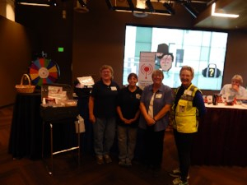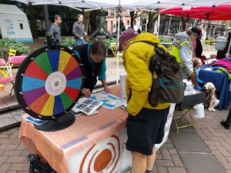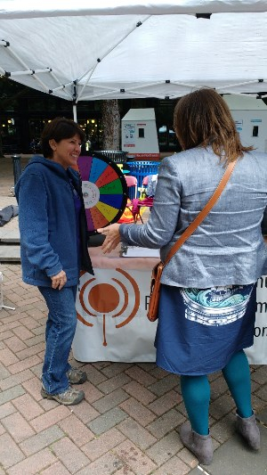

The Hub booth at the Earthquake Shaker event in Occidental Park, Cindi Barker at the table and Ann Forrest out in front  
  
  
Another employee preparedness fair, this time at Holland America

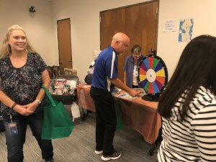

**Help us spread the word about the Hubs**

Trying to explain the hubs and emergency preparedness in Seattle to your friends?  Here’s our newest [brochure for 2017](https://readyseattle.us9.list-manage.com/track/click?u=15c317f52899487470ba6529b&id=3ca6ab8694&e=0b97fdd754).  This has a short description of how the hubs work and what the Seattle Neighbors Actively Prepare (SNAP) program is about.  And don’t forget to check our NeighborLink Map to see if there’s a new hub closer to your house or place of work – we have all the P-Patch hubs that have been put on the map and several additional Communications Hubs as well.  There are also about 10 more hubs that are in the works.

**P-Patch Hubs**

Two additional information sessions were held in October, to help P-Patch garden leaders learn more about the community hub program and to answer questions. We’ve gotten requests for even more information, as some locations are interested in doing some additional training at gardens.   We stand by to help any P-Patch who wants to learn more, so they can grow a hub as their P-Patch community desires.

**Washington State Great ShakeOut**

This is an annual event to focus attention on our Potential for having a major earthquake sometime in the next 50 years.  The state exercise, promoted especially in schools, is to get under a table or assume a safe position at exactly 10:19 on 10/19.  But we think you should do more!  Give yourself a challenge that day.  Pretend the bus system is not working and get yourself home (hey, you have to play fair, no going over a bridge that might be down!).  Turn your cell phone off for 3 hours that evening and don’t use any other electronic devises – remember that power, cell towers and internet will all be severely damaged in a major earthquake.  Cook dinner out of your disaster kit, using only the water and heating source you have in your kit. (and of course, replace it immediately).  Evacuate your family in a surprise drill; do your kids do what you expect them to do?  Take this opportunity to make it real!  [https://www.shakeout.org/home.html](https://readyseattle.us9.list-manage.com/track/click?u=15c317f52899487470ba6529b&id=a2b01fc4fb&e=0b97fdd754)

**Things to do this winter**

Don’t forget to check our website for up coming training available.  In addition to the Stop the bleed mentioned above, the City of Seattle offers classes in light first aid, utilities control, and search and rescue, as well as information sessions on earthquake home retrofits.  You can also look at their website  directly for the classes and resources from the Seattle Office of Emergency Management [calendar](https://readyseattle.us9.list-manage.com/track/click?u=15c317f52899487470ba6529b&id=cb259b6f88&e=0b97fdd754)   
We generally take a breath during the winter, when the summer outreach season tails off.  We’ll be starting the new year with a Seattle Emergency Communication Hub Network Leadership Retreat, where we will set our Network priorities and work plan for the next two years.  We’ll be able to report back to you in the early spring what lies ahead for the Hubs.  One item that we are already working on is our next in-the-field drill, which will most likely be in April or May 2018.  Watch for that and mark your calendar so you can come and help as a hub volunteer or a citizen actor!